# QUEST (QUenching ESTimation)

## Overview

The purpose of the software QUEST (QUenching ESTimation) is to simulate dynamic quenching of xanthene dyes tethers to proteins by flexible linkers by simulating PET and the diffusion of dyes. In QUEST the dyes are approximated by a sphere diffusing within their accessible volume (AV). The quenching by PET of MET, PRO, TYR and TRP residues is approximated by a step function where the dye is quenched with a provided rate contestant if it is closer than a given threshold distance.

Fig. 1 (shown below) presents the interface of QUEST. The Interface is separated into an input/output region (1, to the left) and an output region (2 and 3, to the right). The relevant simulations parameters are set in the region to the left. The simulations results are shown in the region to right. The simulation parameters are briefly listed an explained in Tab. 1. Below the simulation are briefly explained by an example.

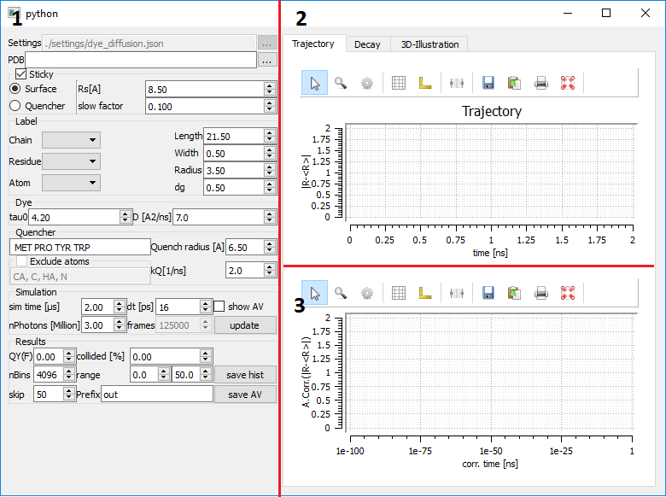

**Fig. 1** Interface of QUEST (1) Input parameters (2) graphical representation of the simulated Brownian dynamics trajectory. The distance between the current position and the average position of the entire trajectory is displayed in dependence of the simulation time (3) auto correlation of the trajectory shown in (2)

**Tab. 1** Simulation parameters and description of simulation parameters

|  |  |
| --- | --- |
| **Parameter name** | **Description** |
| PDB | Open PDB file. Only protonated files are read correctly. The naming scheme has to follow the “PARSE” convention of PDB2PQR |
| Sticky-Checkbox | If this checkbox is checked either the surface of the protein, as determined by the distance to the C-beta atoms, of the quenching amino acids are “sticky”. If this checkbox is unchecked the diffusion coefficient within the accessible volume of the dye is uniform. |
| Rs[A] | A radius (distance) below which parts of the AV are considered as “sticky”. If for instance the distance between these points of the AV and a C-beta atom is smaller than Rs the diffusion coefficient of these AV-points is multiplied by the “slow factor” (see below). |
| Slow factor | The diffusion coefficient of points within the AV which are closer than a critical distance to a stick object are multiplied by this scaling factor. |
| Label-Chain | Chain to which the dye is attached to |
| Residue | Residue to which the dye is attached to |
| Atom | Atom name of the dye attachement |
| Length | Linker-length in Angstroms of the dye |
| Width | Width of the dye-linker in Angstrom |
| Radius | Radius of the dye |
| dg | Grid spacing of the accessible volume |
| tau0 | Fluorescence lifetime of the dye in absence of quenching |
| D | Diffusion coefficient of the dye when not sticking |
| Quencher | A list of quenching amino acids following 3-letter amino acid codes. The amino acids are separated by spaces |
| Quench radius | Distance below which the dye is quenched by an quenching amino acid |
| kQ | Rate constant of quenching |
| Exclude atoms | If this is checked the atoms with the names listed below are not considered as quenching atoms |
| Sim time | Length of the Brownian dynamics (BD) simulation |
| dt | Step length of the BD-simulation |
| nPhotons | Number of simulated photons |
| Frames | Resulting number of simulated frames |
| QY(F) | Simulated fluorescence quantum yield |
| collided | Fraction of dyes which collided with a quenching amino acid |
| nBins | Number of bins of the fluorescence intensity decay histogram |
| range | Range (in nanoseconds) of the fluorescence intensity decay histogram |
| skip | Number of frames which are skipped when BD-simulations are saved or visualized |
| Prefix | Prefix of AV-filenames when saved |

## Example

Before simulating fluorescence decays and fluorescence quenching you have to ensure that the structure of interest is in an appropriate data format. Additionally, crystal water potentially contained in the structure as provided by the protein databank (PDB) should be removed. This is exemplified by a structure (PDB-ID: 172L) of T4 lysozyme (T4L). As can be seen in Fig. 2 the water contained in a crystal structure may exclude a significant fraction of the surface otherwise accessible by the dye. The crystal water should be removed from the structure as potentially accessible quenching sites are otherwise inaccessible.

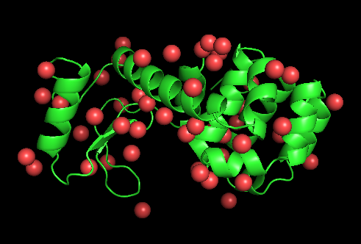

**Fig. 2.** Structure of T4-lysozyme (shown in green) and the crystal water contained in the structure contained in the protein databank (PDB)

Next, the protein structure should be protonated and the naming of the atoms has to be adapted to following the naming convention of the “PARSE” forcefield. This can be accomplished by uploading the protein structure to the PDB2PQR-webserver.

<http://nbcr-222.ucsd.edu/pdb2pqr_2.0.0/>

Download the resulting PQR file and save it as PDB-file. This PDB-file can be opened in QUEST by clicking on (…) highlighted in Fig. 3 by the red number “1”. Next, adjust the parameters to your needs and click on the “update” button to calculate a BD-trajectory and the corresponding fluorescence decay. These steps are shown in Fig. 3.



**Fig. 3.** Steps in simulating fluorescence decays based on a structural model. First open a PDB file (1). Next, (2) update/calculate a BD-trajectory.